**M.I.T. LAB Assignment – 09**

**U19CS012**

1) The Given String Is Stored At Memory Location 1000 Onwards:

”Microprocessor And Interface” Ended With ‘0dh’.  
Write 8085 Program To Count Occurrences Of Each Character In Given String.  
Output Is Displayed From Memory Location 2000

Notepad Code:

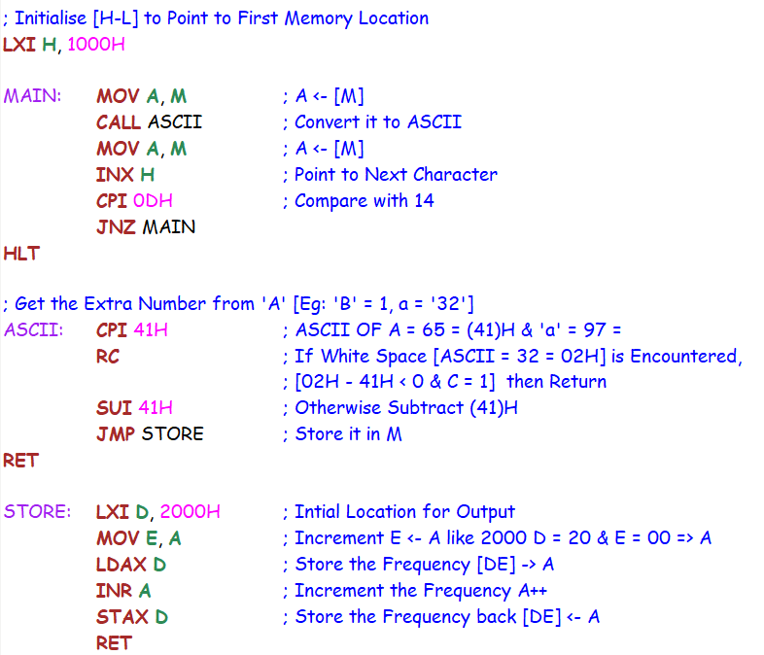

Input:

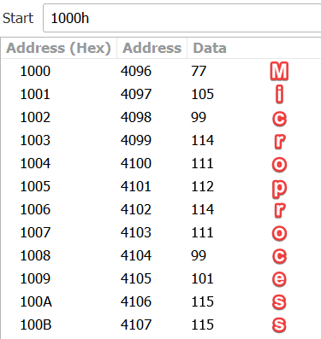 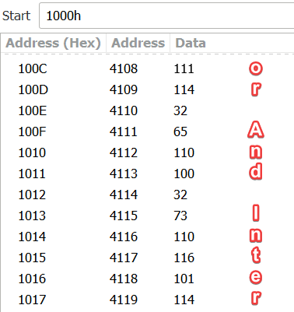

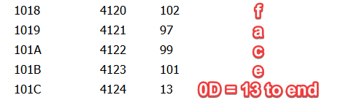

Output:

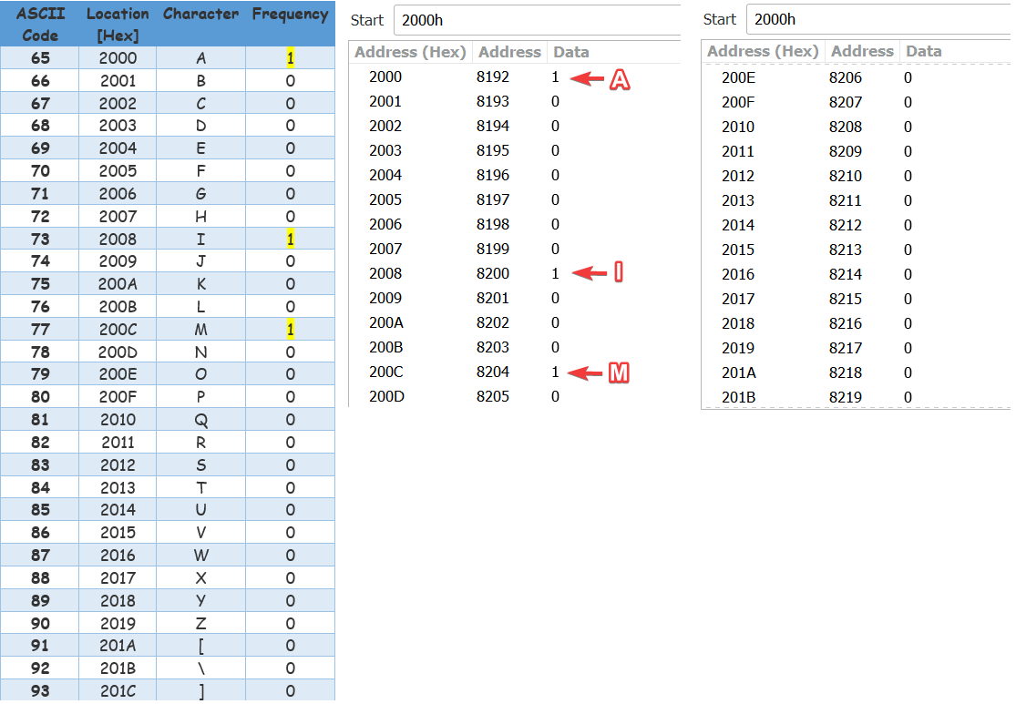

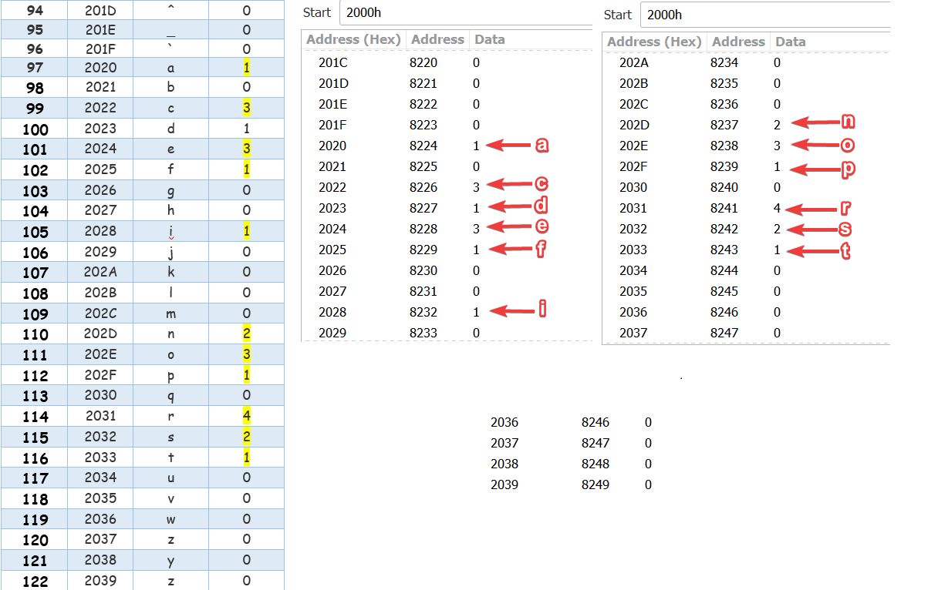

2) Write An 8085 Program To Check The Substring From Given String  
Given String: "Hello World" & Substring: "Wor" => Output : Location of ‘W’

Notepad Code:

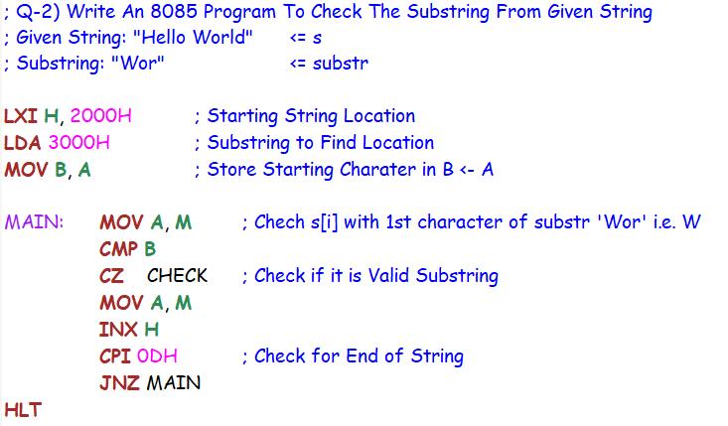

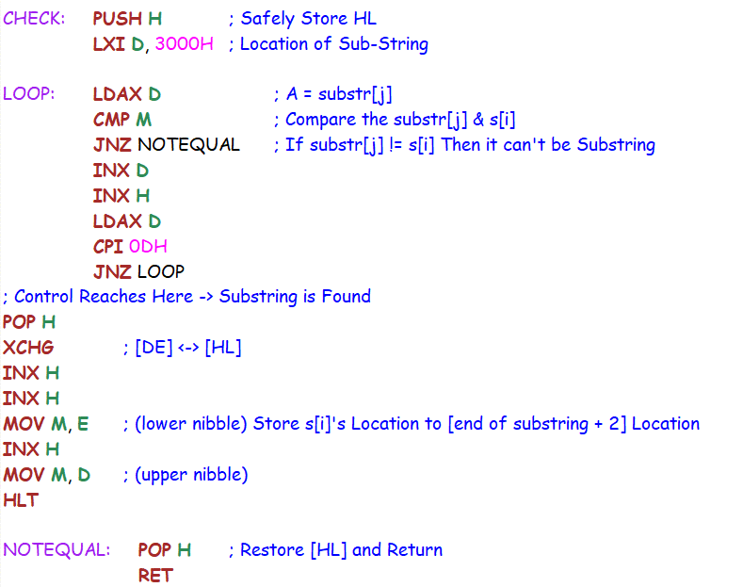

Input:

**String**

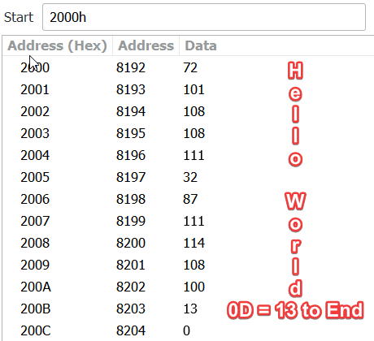

**Substring**

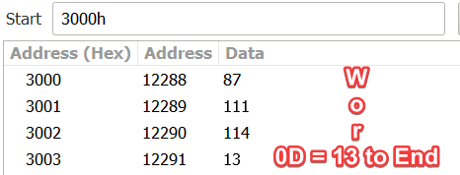

Output:

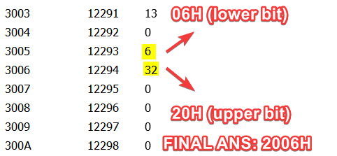

Explanation: ‘Wor’ Substring Starts at Location 2006 H Location in Main String

3) Write An Assembly Language Program in 8085 Microprocessor to Subtract Two 8 Bit BCD Numbers.

Notepad Code:

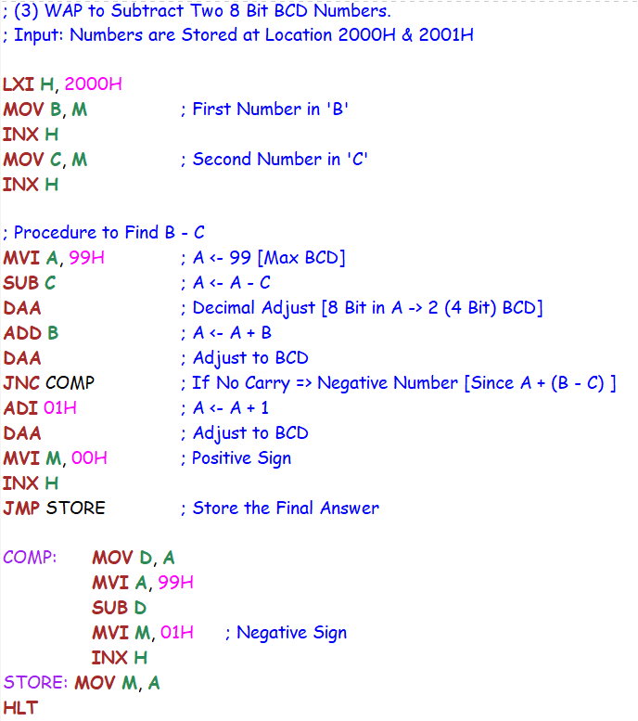

Test Case:

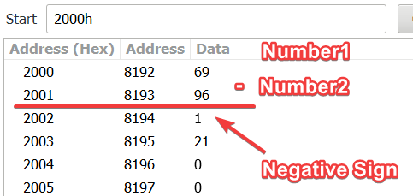 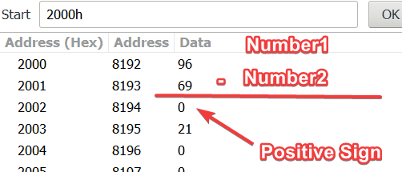

Explanation:

**Case1**: Negative Result

Number1: 45 (in BCD) = (0100 0101)2 = (69)10 [Decimal]

Number2: 60 (in BCD) = (0110 0000)2 = (96)10 [Decimal]

Num1-Num2: -15 (in BCD) = (0001 0101)2 = -(21)10 [Decimal]

**Case2**: Positive Result

Number1: 60 (in BCD) = (0110 0000)2 = (96)10 [Decimal]

Number2: 45 (in BCD) = (0100 0101)2 = (69)10 [Decimal]

Num1-Num2: 15 (in BCD) = (0001 0101)2 = (21)10 [Decimal]

4) Write an Assembly Level Language Program to Convert 8 Bit BCD Number to its Respective ASCII Code.

Notepad Code:

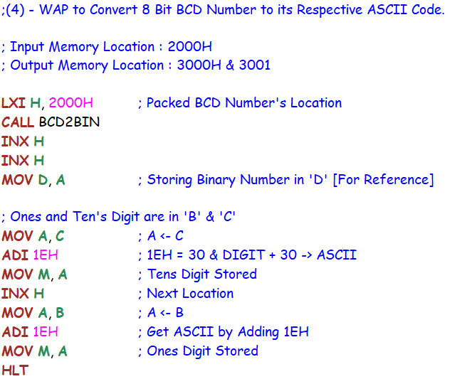

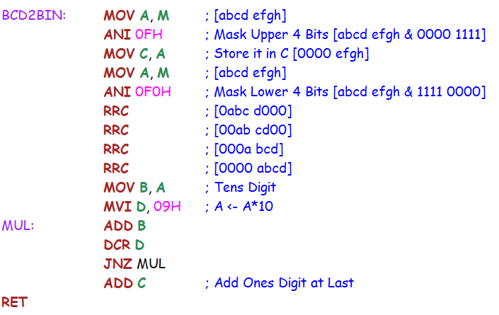

**Test Case:**

Input: Packed BCD = 26 = (0010 0110)2 = (38)10 [Decimal]

Output: ASCII OF 6 = 36 & ASCII OF 2 = 32

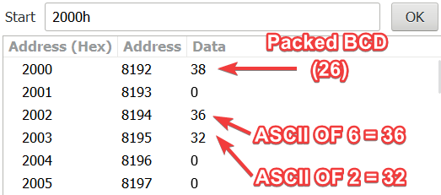

SUBMITTED BY:

BHAGYA VINOD RANA

[***U19CS012***]